**To Pass or To Shoot?**

**An Analysis of 2-on-1 Odd-Man Rush Strategy**

Matthew Palmeri and Steven Czarnecki

**Introduction:**

Over the past 10-15 years, we have seen huge rises in the amount and quality of data when it comes to sports evaluations. Baseball has seen the rise of the StatCast system measuring every detail of a pitch, Football has Next Gen Stats, and Hockey will soon have player and puck tracking data. However, none of this data is publicly available. When it comes to answering important questions (like classifying routes in the NFL, the NFL big data contest question from last year’s contest), you either have to painstakingly collect the data by hand, work for an institution that has access to this data, or pay for this data. Through the inaugural CBJ Hockey Analytics Conference, and their partnership with SportLogiq, we have gotten access to spatio-temporal data from 575 games from the 2018-2019 AHL season.

With this SportLogiq data, we decided to investigate how goals are scored on 2-on-1 odd man rushes. With SportLogiq data, we have the ability to look at the impact of handedness, entry location, defender location, and the impact of specific events like passes. This information could help guide both offensive and defensive strategy when it comes to converting or neutralizing them respectively.

**Methods:**

*Data Manipulation:*

To be able to properly gauge the effect of passing on a 2-on-1, we need to gather as much information about each 2-on-1 event as we can. Using SportLogiq’s spatio-temporal dataset from a sample of AHL games in the 2018-2019 season, we were able to gather information such as the location of the entry, the location of the defenseman on the entry, whether a pass occurred, and much more.

From the 575-game sample, there were 1151 5v5 2-on-1 events (signified by a controlledentryagainst event name with a 2on1 type), which was filtered to 864 2-on-1 events by removing events where the goalie was designated the defending player on the 2-on-1, or there were no attacking events within a second of the controlledentryagainst event. The latter case was removed so that we had consistent information on where the entry happened, and who the possessing player was on the entry. To prevent events outside the 2-on-1 event from affecting our samples and calculations, we cut-off events 3 seconds after the controlled entry event occurred. Once 2-on-1 events were chosen, we then set out to gather as much information about each 2-on-1 event as possible:

* Passes (Number of Attempted, Successful, Blocked, Attempted Pass Blocks)
* Outcome (Goal or Not)
* Shooting (Successful, Attempted, Blocked, as well as Slot or not breakdown)
* Possession Player Information (Position, Handedness, x-y location of entry)
* Speed of Possessing Player on Entry
* Defending Player Information (Position, Handedness, x-y location on entry)
* Distance between Possession player and Defending player

*Data Analysis:*

To determine the impact of passes on the success of a 2-on-1, we used several variable selection techniques and intentional control variables to create a best-fitting reduced model that explained whether a goal was scored or not on a 2-on-1. We then ran a drop-in deviance test to see if the addition of information on whether a pass was attempted provide significant additional explanatory power to the model.

In addition to looking at the impact of attempted passes on a goal being scored, we also look at quantifying both the risk and reward of making a pass, by seeing the impact of a successful pass on scoring, as well as the impact of attempting a pass on getting a shot off on the 2-on-1.

**Results:**

As outlined above in the Data Analysis section, we created a best fitting reduced model to predict whether a goal was scored or not, denoted MR below:

*MR: Goal ~ Distance + AttackingSameHandedness + PreEntrySpeed + DefendingSameHandedness + AttemptedShots*

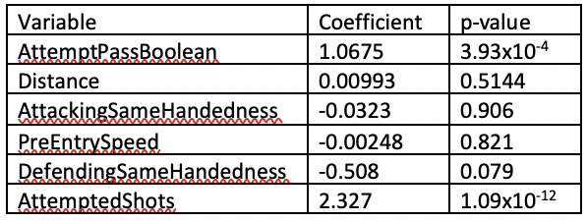In this model, we include controls for the distance between the possessing player on entry and the defending player on entry (Distance), handedness and the side the possessing player entered on (AttackingSameHandedness), the speed of the player on entry (PreEntrySpeed), the relationship between the side the possessing player entered on, and the defending player’s handedness (DefendingSameHandedness), and the number of shots that were attempted on the 2-on-1 (AttemptedShots). To then understand the impact of an attempted pass, we added a boolean value to indicate whether a pass was attempted on the 2-on-1. The coefficients and significance test p-values are included below in table 1. The drop-in deviance test for the addition of the AttemptedPassBoolean variable gave a deviance difference of 17.504 with 1 degree of freedom for a p-value of 2.27x10-4. This indicates that a pass being attempted has a significant positive impact on whether a goal was scored or not. This coefficient of 1.0675 for AttemptPassBoolean also gives us insight into the odds ratio of success for 2on1 with an attempted pass and those without an attempted. This tells us the odds of scoring with an attempted pass are almost 3 times as high as the odds of scoring without an attempted pass.

Table 1: Coefficient and significance measures for MR with AttemptPassBoolean

While not necessary a main focus, we also see some relationship between the DefendingSameHandedness variable and whether a goal was scored or not. While not below the typical significance threshold of 0.05, this negative pattern was prevalent in most models built throughout the variable selection process. This negative coefficient means for example, that when the player with possession of the puck enters the zone on the right side of the defensive player (from the perspective of the attacking players), and the defending player is right-handed, you are less likely to score a goal. This makes some sense, as it might be easier for the defending player in this situation to have their stick in the shooting lane, and body in the passing lane.

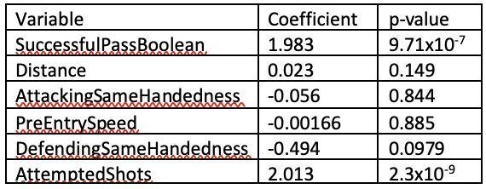 In addition to this evidence that attempting to pass has a positive relationship with a goal being scored, we also looked at both the impact a successful pass has on scoring a goal, and the impact attempting to pass has on getting a shot off on the 2-on-1 to better understand the risk/reward of making a pass on a 2-on-1. Using the same MR from above, we looked at the impact SuccessfulPassBoolean (boolean variable to indicate whether a pass was successful on the 2-on-1) had when added. What we see from table 2 is that a successful pass has a positive relationship with a goal being scored, and that its impact is even greater than with an attempted pass. The 1.983 coefficient on SuccessfulPassBoolean tells us that 2-on-1 events with a successful pass have nearly 7 times the odds of scoring compared to those without a successful pass. We also looked at the impact passes on a 2-on-1 had on a shot being attempted, using the model below denoted MP:

Table 2: Coefficient and Significance Measures for MR with SuccessfulPassBoolean

*MP: AttemptShotBoolean ~ AttemptPassBoolean + PreEntrySpeed + Distance*

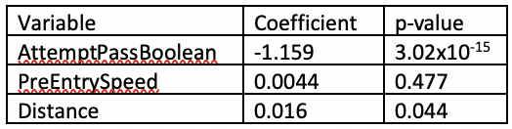Coefficients for MP can we seen in table 3 to the right. We see a highly significant negative relationship between attempting a pass and getting a shot off. This coefficient means that 2-on-1 events with an attempted pass have roughly 0.33 times the odds of getting a shot off compared to 2-on-1 events without a pass. We also see in Table 3 a significant positive relationship between the Distance (distance between attacking player with possession on entry and defending player) and a shot being attempted. We see this same positive relationship, although not always significant, in both Table 1 and Table 2, indicating that this distance also has a positive relationship with a goal being scored.

Table 3: Coefficient and Significance Measures for MP

**Discussion:**

In summary, our findings show that the reward outweighs the risk when passing the puck on a 2-on-1 odd-man rush. We found that attempting to pass the puck can decrease your odds of getting a shot off by 0.33 times, but if that pass is successful, your odds of scoring increase by nearly 7 times your odds otherwise. In addition, we found a significant positive relationship between attempting a pass and scoring a goal, which further backs up our claim that when holding handedness, entry speed, and the distance between attacking and defending players constant, you have better odds of scoring when you pass the puck.

While we found significant results, there are several limitations in this study, and room for future improvement. Due to wanting a dataset with complete information about entry location, nearly a third of all 5v5 2-on-1 events were excluded. It is difficult to determine which way this exclusion might have biased the results, but in could certainly have had an impact. While SportLogiq’s spatio-temporal dataset has location information of events, it doesn’t have 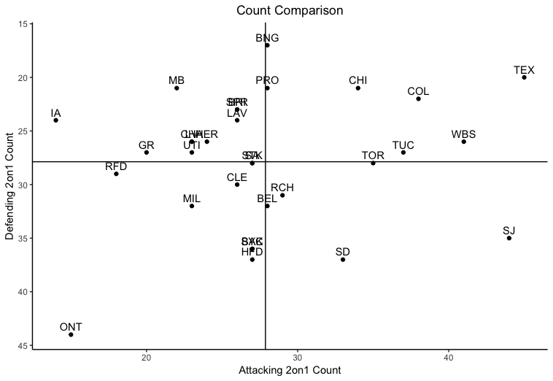spatio-temporal data for each player. Because of this, we don’t really have any knowledge for where each player was positioned in relation to each other after the entry event. This means we can’t further analyze the impact of specific defensive strategies like attacking the puck carrier, taking away the pass option by blanketing the other attacking player, or trying to play in the middle.

In addition to further research dealing with the above potential issues, there is also a lot of room to build off of these findings. While certainly not a focus on this research, we did look at team trends in the number of 2-on-1 events both for and against. Looking at Figure 1, Future research could see if teams like the Texas Stars had some system elements or playstyle elements that lead to lots of 2-on-1 events for them, with few against. Similarly, you could look at the Ontario Reign and see if their playstyle or system can lead to lots of 2-on-1 events against with few 2-on-1 events for. This work could go beyond just looking at how to successfully score or defend a 2-on-1, but how to generate or prevent them from happening in the first place.

Figure 1: Comparison of the number of 2-on-1 events for (Attacking) and against (Defending). Note that the y-axis (Defending/Against) is inverted.